India Macro Indicators Policy Brief

Executive Summary:
India’s macroeconomic performance over 2015–2025 reflects resilience amid significant disruptions particularly the COVID-19 shock. Growth recovered strongly post-2020 supported by fiscal expansion and rising investment inflows. However, inflation volatility, persistent external imbalances and elevated fiscal deficits remain key concerns. Policy focus must shift toward sustainable growth, inflation control and external balance management. The analysis highlights three core themes:
- Strong recovery but uneven stability
- Inflation and external sector remain vulnerable
- Investment flows are a major positive driver

Key Findings (Across Indicators):
- GDP shows a V-shaped recovery post-2020
- Inflation spikes align with global supply shocks and currency pressure
- Fiscal deficit widened significantly during crisis periods
- Trade imbalance persists as imports consistently exceed exports
- CAD remains volatile reflecting external vulnerability
- FDI inflows indicate long-term investor confidence in India

Indicator wise Insights & Recommendations:
1. GDP Growth:
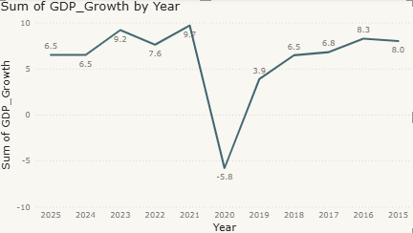
Insight:
GDP experienced a sharp contraction in 2020 followed by a strong rebound indicating resilience but also exposure to global shocks.
Recommendation:
Focus on diversifying growth drivers like manufacturing and exports to reduce dependence on consumption led recovery.

2. Inflation (CPI):
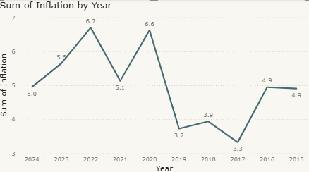
Insight:
Inflation surged during 2020–2022 due to supply chain disruptions and exchange rate pressures because of COVID.
Recommendation:
Strengthen monetary fiscal coordination to control inflation while maintaining growth momentum.

3. Fiscal Deficit:
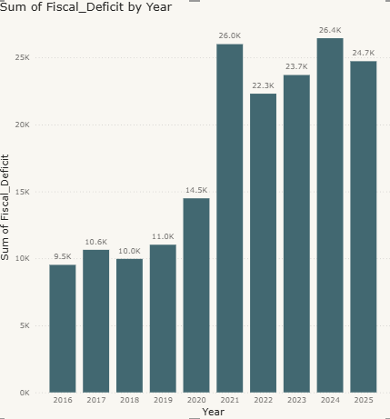
Insight:
Fiscal deficit expanded significantly during the pandemic and remains elevated.
Recommendation:
Implement gradual fiscal consolidation while prioritizing capital expenditure over revenue spending.
4. Trade & Current Account Deficit (CAD):
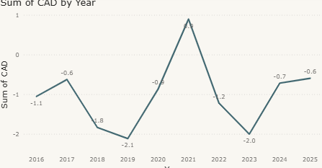
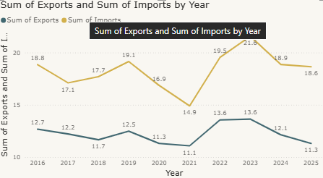
Insight:
Persistent trade deficit drives CAD volatility making the economy vulnerable to global shocks.
Recommendation:
Promote export competitiveness and reduce import dependence.
5. FDI & Investment:
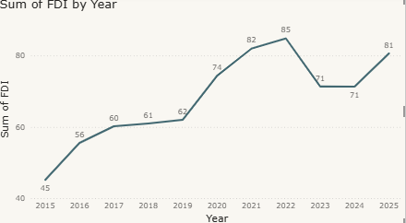
Insight:
FDI inflows increased significantly post-2020 reflecting strong investor confidence.
Recommendation:
Sustain reforms that improve ease of doing business and sectoral liberalization.

Scenario Analysis:
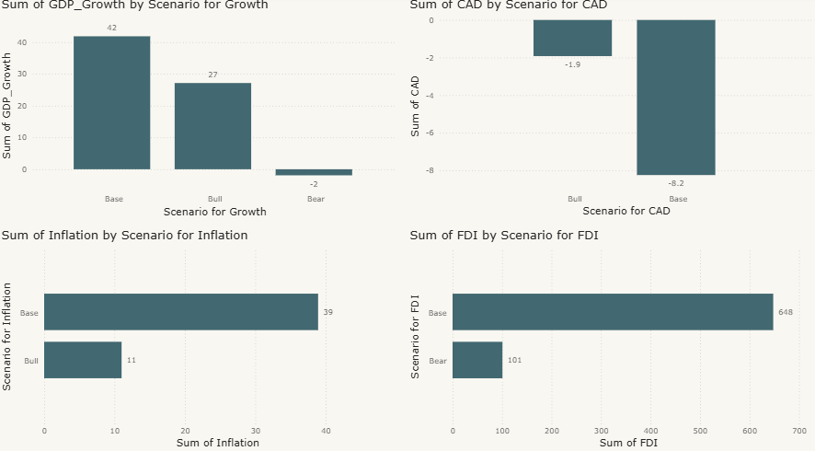
- Bull Case: High growth, controlled inflation, strong FDI
- Base Case: Stable growth with moderate inflation
- Bear Case: Slower growth, higher inflation, widening CAD
Policy Implication:
India must prepare for downside risks by maintaining macroeconomic stability buffers.

Conclusion:
India’s macroeconomic trajectory demonstrates resilience but also structural challenges. Sustaining long-term growth requires balancing:
- Growth vs inflation
- Fiscal expansion vs sustainability
- External openness vs vulnerability

